FACULTY PROFILE
Name | Dr. P.S. KIRAN KUMAR | 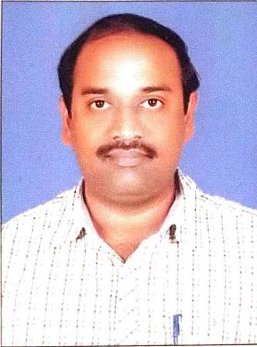
Department | Department of English
Designation | Regular faculty
Date of Appointment | 22-12-2000
Date of Birth | 21-07-1975
Contact Number | 9290461736
Email Id | kiranneerada@gmail.com
Academic qualifications:
Qualification | Name of the University | Year of passing
Ph. D | Acharya Nagarjuna University | 2019
M.A | M.A(English) ,ANU | 1998
Others Qualifications (NET/SET etc.), if Any | M.A.(History), ANU  M.Phil, MKU | 2018  2011
Experience Details:
Designation | Name of the Institution, Place | From | To
Regular Faculty | VRS & YRN College, Chirala | 2000 | 2021
Regular Faculty | SKP GDC, Guntakal | 2021 | Till now
Total Teaching Experience: P.G Classes: __Years
U.G Classes: ____24___Years.
Research Experience Including Years spent in M.Phil/Ph.D:
Fields of Specializations under the subject/Discipline:
a.
b.
List of research Publications/Books:
Title of the Paper | Journal | Year of Publishing | UGC CARE/SCI/SCOPUS etc.
List of Projects Completed:
Title of the Project | Sponsoring Agency | Major/Minor | Total Grant Received | Year of Completion
List of OC/RC/TOTs/FDP/MOOCS/ARPIT Attended:
Title of the course | Type of the Course (FDP/RC Etc.) | Duration | Organized by
Englislanguage teaching to the fourth industrial revolution | FDP | 07 days | Bharat Institute of engineering and technology, Hyderabad
SEEK&SELL | FDP | 01 day | CCE
NEP 2020 Teacher training programme | Orientation&sensitization | 09 days | SVUniversity, Tirupati
Co-Curricular, Extension and Professional Development Related Activities:
S.No | Name of the Activity | Details
1 | Student related Co- Curricular, extension and field-based activities (such as extension work through NSS/NCC and other channels, Cultural activities, subject related events and counseling.
2 | Contribution in corporate life and management of the department and participation in academic and administrative committees and responsibilities and Professional Development.
Awards/ Achievements: Please give details of any other credentials, significant contributions, awards received:
S.No | Name of the Award/Achievement | Date of Receiving
1

